Reconciliation Report for Qube Active Tenancies
Version 1 | 23/04/2025

Grainger PLC
Single View of Tenancy

Contents
1. Tenancies: 3
1.1 Initial Data Extract 3
1.2 Pre-Processing and Deduplication 3
1.3 Verification Against Salesforce 3
1.4 Insert Tenancies into SALESFORCE 3
2. Opportunities 5
2.1 Initial Data: 5
2.2 Linking Opportunities to Migrated Tenancies by unit 5
2.3 Selecting the Most Recent Opportunity 5
2.4 Update Opportunities in Salesforce 5
3. Contracts 7
3.1 Initial Data 7
3.2 Residential Contract Validation 7
3.3 Association with an Opportunity 7
3.4 Association with Migrated Tenancy 7
3.5 Account Matching Validation 7
3.6 Update Contracts in Salesforce 7
3.7 Update Failures 7
4. End of Tenancies 10
4.1 Initial Data 10
4.2 Association Check 10
4.3 Status Filtering 10
4.4 Update EOTs in Salesforce 10
4.5 Update Failures 10

- Tenancies:
(See Fig 1)
- Initial Data Extract
- Source: Qube Active Tenant Extract
- Initial Count: 49,768 rows
- Step: Filter out multi-tenant entries by checking the "Com Tran" value.
  - Rows Discarded: 20,695 (Multi-Tenant)
  - Retained: 29,073 (Single-Tenant or Sharer)

- Pre-Processing and Deduplication
- Get Distinct Tenancies Per Unit:
  - If multiple tenancies exist for the same unit (9,884 rows), keep only the "newer" tenancy.
  - Yes → 9,884 rows discarded
  - No → 19,819 rows retained
- Qube Missing Salesforce Contact ID?
  - Yes → 37 (No contact ID) rows discarded
  - No → 19,782 rows retained
- Check for Duplicates in Qube (same unit & tenancy):
  - Yes → 109 (Only keep newest) rows discarded
  - No → 19,673 rows retained

- Verification Against Salesforce
- Check if Unit Exists in Salesforce:
  - No → 7 (Units not in SF) rows discarded
  - Yes → 19,666 rows retained
- Check if Contact Exists in Salesforce:
  - No → 44 (Contacts not found) rows discarded
  - Yes → 19,622 rows retained

- Insert Tenancies into SALESFORCE
- Insert Records into Salesforce:
  - Success: 19,622
  - Failures: 0

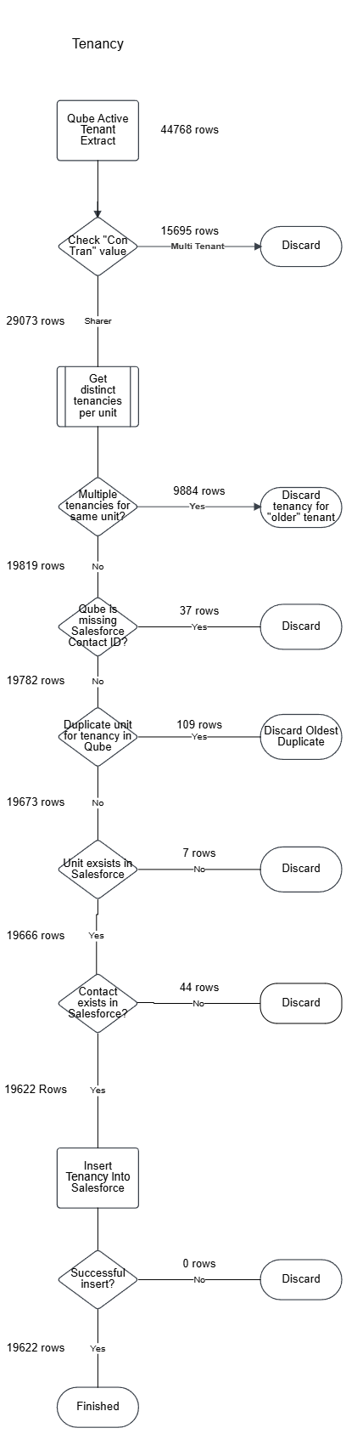
Figure 1
- Opportunities
(See Fig 2)
- Initial Data:
- Opportunities in UAT:
  - Total records: 46,399

- Linking Opportunities to Migrated Tenancies by unit
- Condition: Is the opportunity linked to a migrated tenancy by unit ID?
  - No → 6,302 rows discarded
  - Yes → 40,097 rows retained

- Selecting the Most Recent Opportunity
- Step: Filter for the most recent "New" and "Renewal" opportunities per tenancy.
- After applying this logic:
  - Remaining rows: 26,503
  - These include:
    - 2,834 linked by PMS Reference
    - 23,669 linked by Unit
- Outdated Opportunities (not the most recent "New" and "Renewal" opportunities for a given tenancy):
  - 16,428 rows discarded as outdated opportunities

- Update Opportunities in Salesforce
- Update Records in Salesforce:
  - Success: All 26,503 rows successfully updated
  - Failures: 0 failed updates

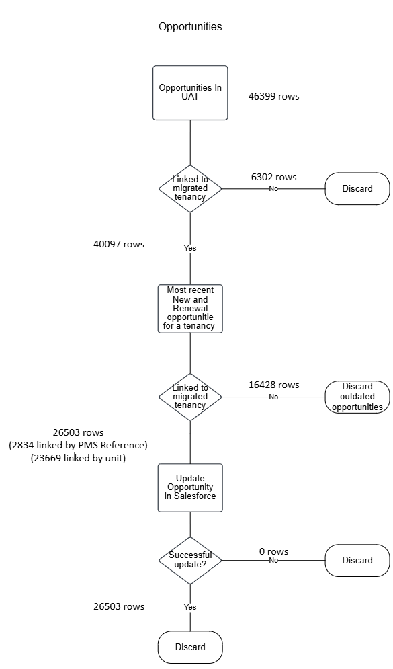
Figure 2
- Contracts
(See Fig 3)
- Initial Data
- Contracts in UAT:
  - Total contracts: 32,210

- Residential Contract Validation
- Check: Is the contract a Residential Contract in UAT?
  - No → 191 rows discarded
  - Yes → 32,019 rows retained

- Association with an Opportunity
- Check: Is the contract associated with an opportunity in UAT?
  - No → 2,478 rows discarded
  - Yes → 29,541 rows retained

- Association with Migrated Tenancy
- Check: Is the contract associated with a migrated tenancy?
  - No → 12,976 rows discarded
  - Yes → 16,565 rows retained

- Account Matching Validation
*Documented but not enforced during migration due to frequent ambiguity in identifying the lead tenant in the Qube extract, which often causes mismatches.
- Check: Does the account on the updated contract match the account on the migrated tenancy?
  - No → 4,268 rows fail this check but were not discarded in this migration
  - Yes → 12,297 rows retained

- Update Contracts in Salesforce
- Attempted updates: 16,565 contracts
  - Success: 16,515
  - Failures: 50

- Update Failures
- Failure Reasons:
  - 2 rows failed due to validation exception (bad data in Agreement_Type in UAT)
  - 48 rows failed due to inability to reset contract status (caused by conflicts with previously migrated Qube production data)

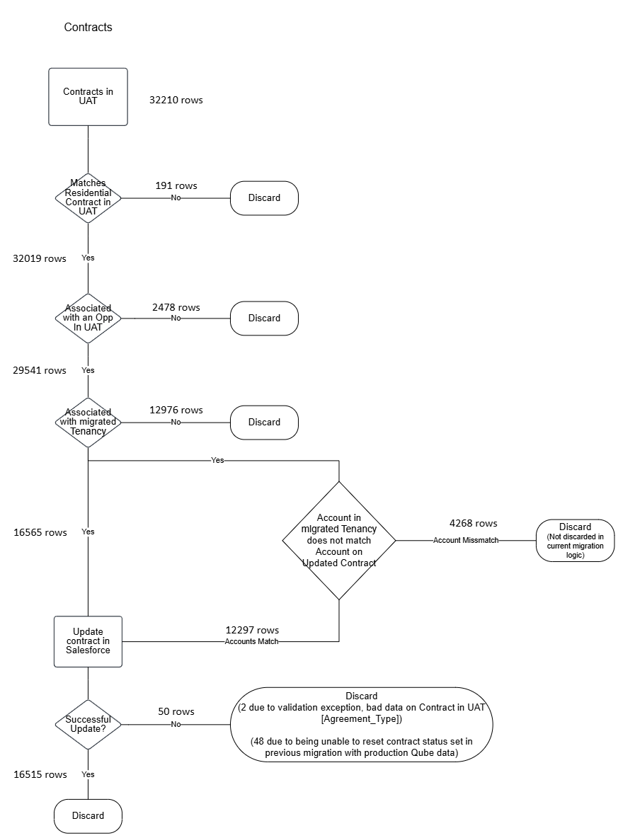
Figure 3

- End of Tenancies
(See Fig 4)
- Initial Data
- EOTs in UAT:
  - Total rows: 1,583

- Association Check
- Check: Is the EOT linked to both a contract that is linked to a migrated tenancy?
  - No → 872 rows discarded
  - Yes → 711 rows retained

- Status Filtering
- Check: Is the EOT in an Active, Pending, Cancel, or Closed status?
  - No → 77 rows discarded
  - Yes → 634 rows retained

- Update EOTs in Salesforce
- Attempted Updates: 634
  - Success: 632
  - Failures: 2 rows

- Update Failures
- Failure Reasons:
  - Validation Exception: Mismatch in Actual_vacate_Date__c between EOT and Tenancy
  - These 2 rows were discarded

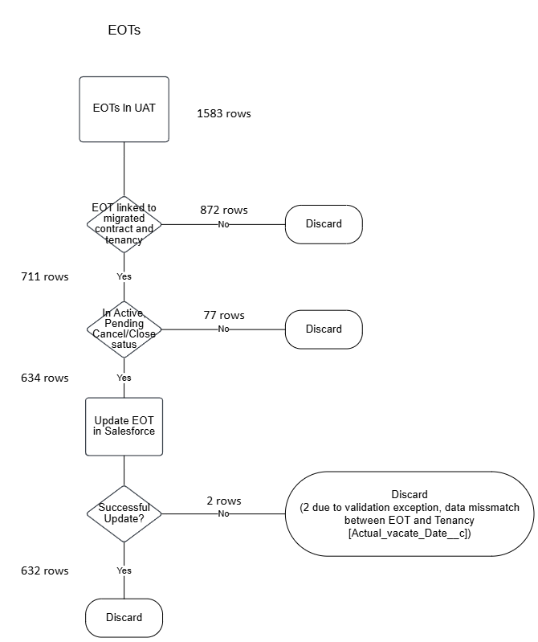
Figure 4

